FORM III
(Refer regulation 7(1))
Bureau of Energy Efficiency
REGISTER CONTAINING LIST OF ACCREDITED ENERGY AUDITORS

Serial Number (AEA- 148) As on -(26/11/2013)
A. | Accreditation information in respect of accredited energy auditor
1 | Name of accredited energy auditor | RAM NARAYAN VAISHNAWA | 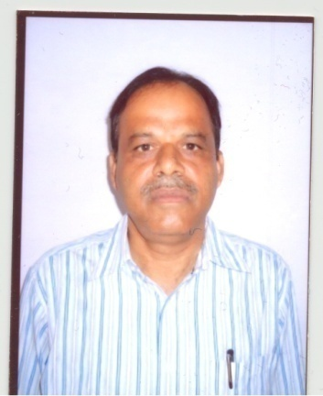  Photograph of the energy auditor
2 | Father’s name | LATE SH.RAMESHWAR LAL VAISHNAWA
3 | Date of certification as Energy Manager | 07-02-2013
4 | Date of passing the examination in “Energy Performance Assessment for Equipment and Utility Systems” | 31-08-2004
5 | Examination Registration Number of  (i) Energy Manager  (ii) “Energy Performance Assessment for Equipment and Utility Systems” | EA-1879  EA-1879
6 | Certificate Registration Number of  (i) Energy Manager  (ii) “Energy Performance Assessment for Equipment and Utility Systems” | 0753 (by BEE)  0409 (by NPC)
7 | Date of issue of accreditation certificate | ( to be filled by BEE)
8 | Professional postal address with Pin Codes of the accredited energy auditor | Ram Narayan Vaishnawa  Superintending Engineer (RDPPC), AVVNL  60-61, Mayur Colony, Near Ram Mandir,  Gulabpura-311021, Distt: Bhilwara (Rajasthan)
9 | E-mail address | rnvaishnawa1879@gmail.com
10 | Telephone numbers with STD Code  (R)  (O)  Mobile No. | +91 9413924454  +91 9660656060  +91 9414068497
11 | Remarks

