FORM III
(Refer regulation 7(1))
Bureau of Energy Efficiency
REGISTER CONTAINING LIST OF ACCREDITED ENERGY AUDITORS

Serial Number (AEA- 0006) As on:- 26 February, 2013
A. | Accreditation information in respect of accredited energy auditor
1 | Name of accredited energy auditor | Abraham Varughese | 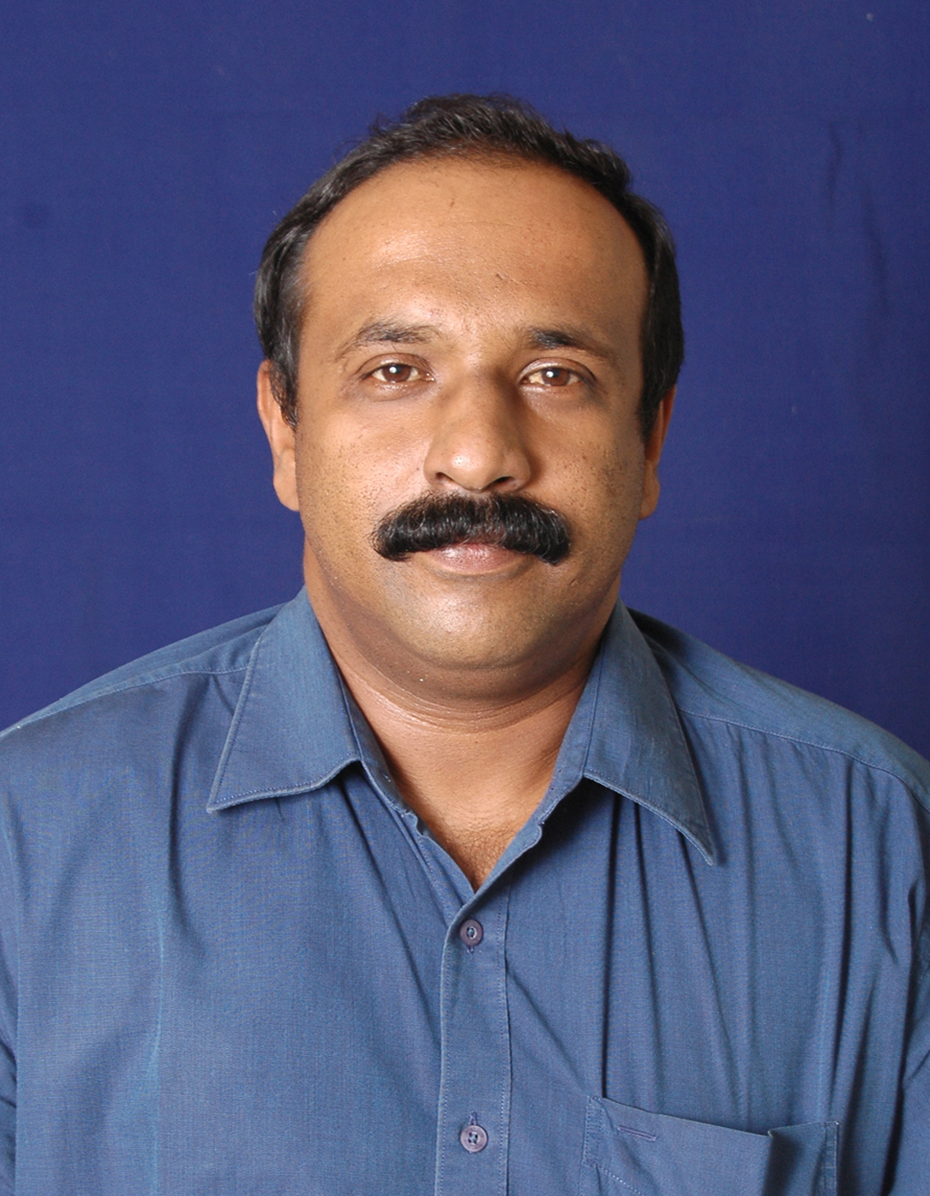
2 | Father’s name | Varughese P.A
3 | Date of certification as Energy Manager | 18.11.2005
4 | Date of passing the examination in “Energy Performance Assessment for Equipment and Utility Systems” | 18.11.2005
5 | Examination Registration Number of  (i) Energy Manager  (ii) “Energy Performance Assessment for Equipment and Utility Systems” | EA-0079
6 | Certificate Registration Number of  (i) Energy Manager  (ii) “Energy Performance Assessment for Equipment and Utility Systems” | No.0481
7 | Date of issue of accreditation certificate | ( to be filled by BEE)
8 | Professional postal address with Pin Codes of the accredited energy auditor | Schneider Electric India Pvt. Ltd.  4th Floor, Electra, Wing ‘A’ Exora Business Parks, Marathalli, Sarjapur, Outer Ring Roads, Bangalore – 560 013
9 | E-mail address | abraham.varughese@schneider-electric.com
10 | Telephone numbers with STD Code  (R)  (O)  Mobile No. | (R) = 9845471135.  (O) = 080-43333333  Mobile No : 9845471135.
11 | Remarks | NIL

