Press release for Workshop on “Energy Efficiency Financing - Pioneering New Markets”
Bureau of Energy Efficiency (BEE) in partnership with Energy Management Centre (EMC), Kerala organized a workshop on 22nd August, 2017 on “Energy Efficiency Financing- Pioneering New Markets” at Thiruvananthapuram. The objective of this platform is to interact with financial institutions and project developers for their capacity building in implementation of energy efficiency projects.
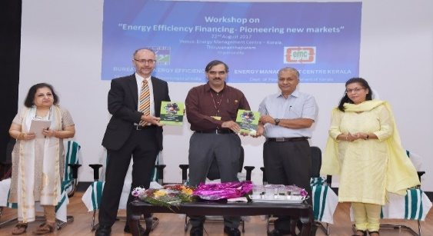
The purpose of this workshop was to discuss the growing investment potential in energy efficiency sector and to attract financing from banks & financial institutions. In the inaugural session, Director General, BEE launched the “Energy Audit Manual” that has been prepared jointly by EMC and National Productivity Council (NPC).
The workshop was attended by about 100 officials representing industries, PSUs, energy auditing firms, energy managers, energy auditors, municipalities, State Designated Agencies (SDAs) and other stakeholders. Speakers from BEE, IFC, SIDBI, ESCOs, KfW, industries deliberated upon opportunities and challenges in EE financing. However, ESCOs raised their concern on challenges in getting the projects as well as non-existence of secured mechanism to get the payment from hosts where EE projects are implemented. It was discussed that because of this non-existence of secured payment mechanism these projects are considered as very risky by Financial Institutions (FIs) and this creates hurdles in financing EE projects.
Director General, BEE in his concluding remarks urged the FIs to put a thrust to financing of energy efficiency projects for pioneering new markets in energy efficiency. It was also indicated that BEE shall modify the existing structure for ESCO market to boost up this business and provide solution to challenges faced by the ESCOs.

